Project B: Gigantic 3D World with Camera Control

Yiming Dai YDF9097

* **Goal**

The goal of the project was to create a 3-dimensional world with several interesting shapes that user can explore this gigantic ‘virtual world’. The program will automatically re-size its 3D graphics to fill the full width of browser window, showing 2 re-sized camera views side-by-side, with an orthographic view on the right, and perspective view on the left. At least one moving object would have diffuse shading. The 3D world you explore will have patterned, grid-like ‘floor’ plane that stretches out to the horizon in the x,y directions, World-space +z points ‘up’ to the sky. Arranged on the vast floor, there are several animated, jointed solid objects that user can explore by ‘flying’ around, between and behind them.

* **User’s instructions**

Upon opening the html file in the browser, there is a gigantic 3D ‘virtual world’, an instruction part and a control panel.

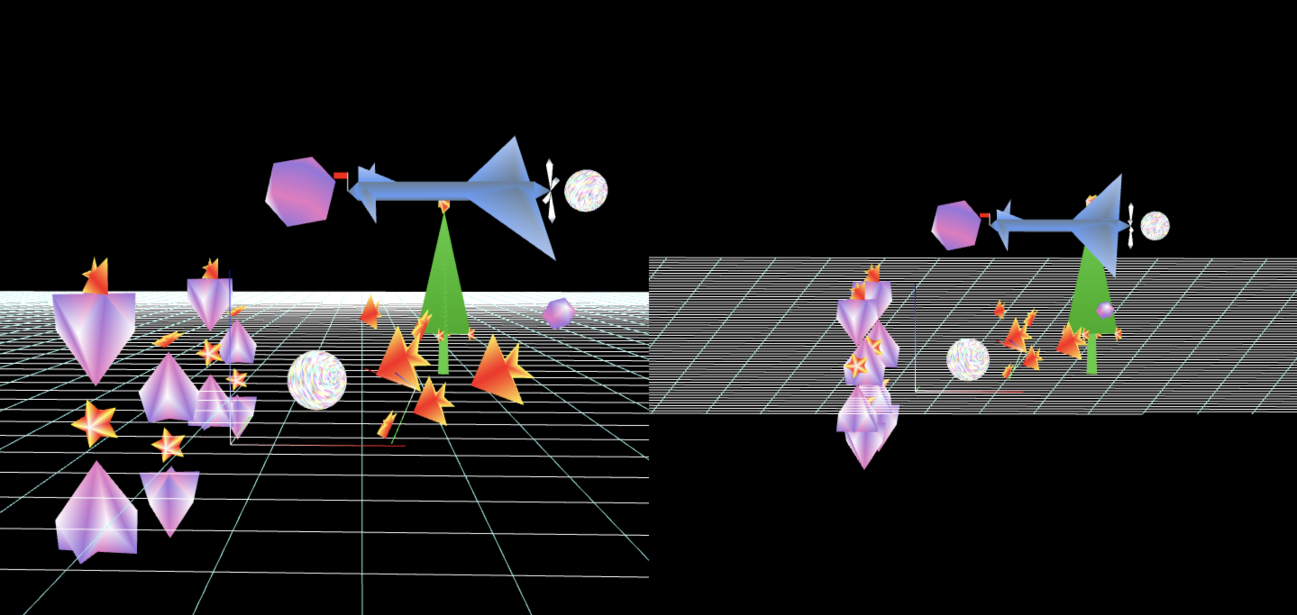

Figure 1 original world

Figure 1 above shows the 3D world. There are several jointed objects moving on the screen. The left part is perspective view and the right part is orthogonal view.

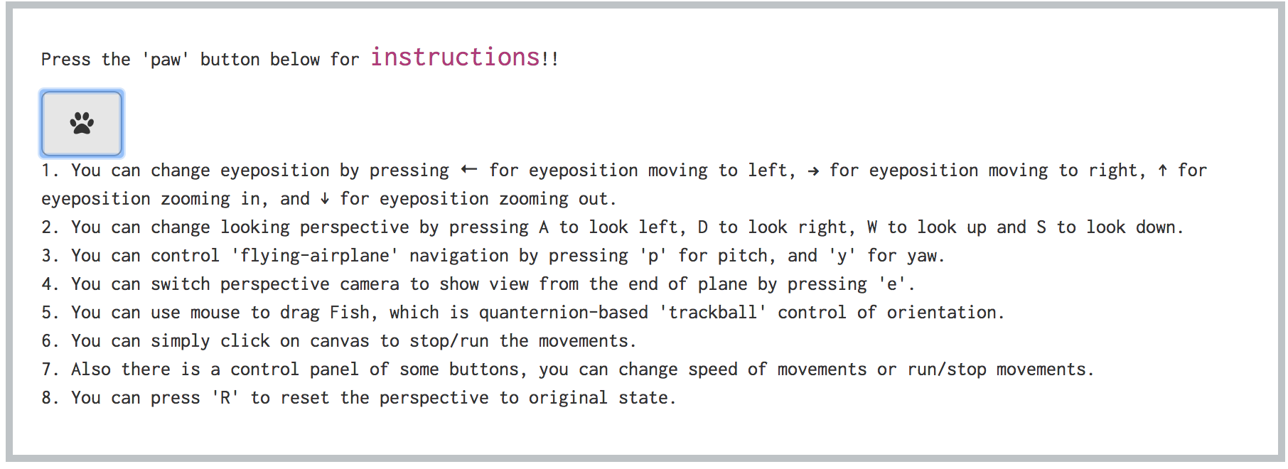

Figure 2 user instructions

Figure 2 above shows user instructions. By pressing the ‘paw’ button, instructions will show up. And user can follow instructions to know how to alter objects on the screen and move the camera around the world space.



Figure 3 control panel

Figure 3 above shows a control panel. User can control states of movements.

* **Results**

Below are some pictures showing the program results. The original world is shown in Figure 1. There is a plane flying on the sky, and there is a tree and a sphere spinning on the ground. There are also 4 spinning combination of tops, fish, star on the left part. And there are several fish on the right part, which user can use mouse to drag it. This is quanternion-based ‘trackball’ control of orientation.

By following instructions, user can alter objects on the screen and move the camera around the world space.

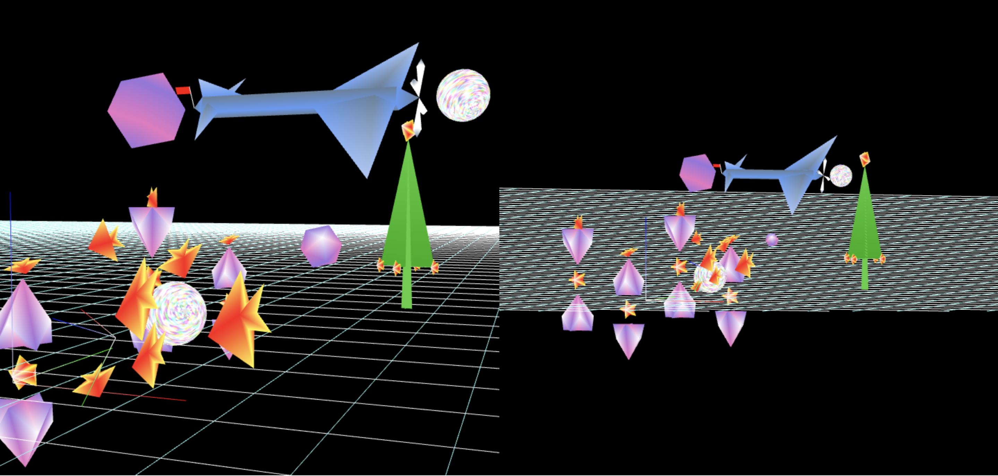

Figure 4 change looking perspective & eye position

Figure 4 shows a result of changing looking perspective and eye position.

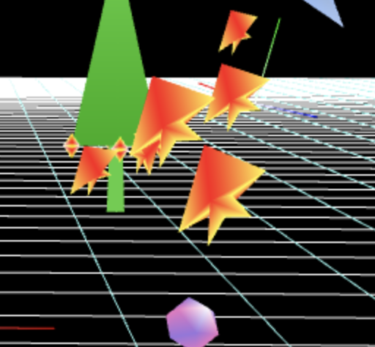

Figure 5 quanternion-based 'trackball' control of orientation

Figure 5 shows a result of mouse drag, which is quanternion-based 'trackball' control of orientation.

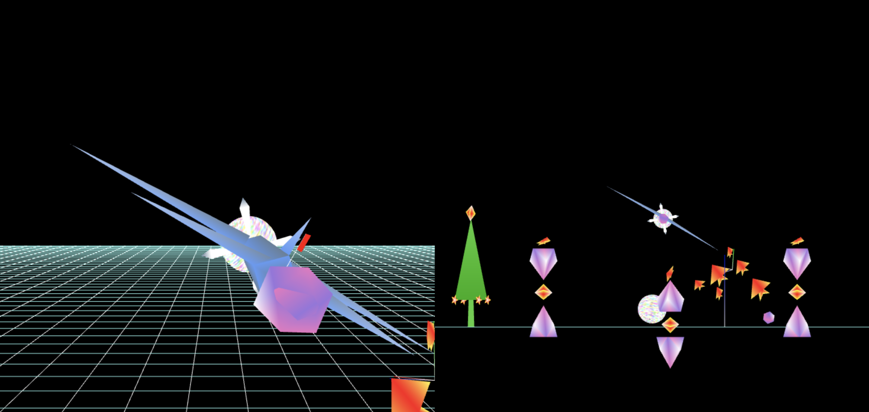

Figure 6 switching perspective camera

Figure 6 shows the result of switching perspective camera to show view from the end segment of animated object.

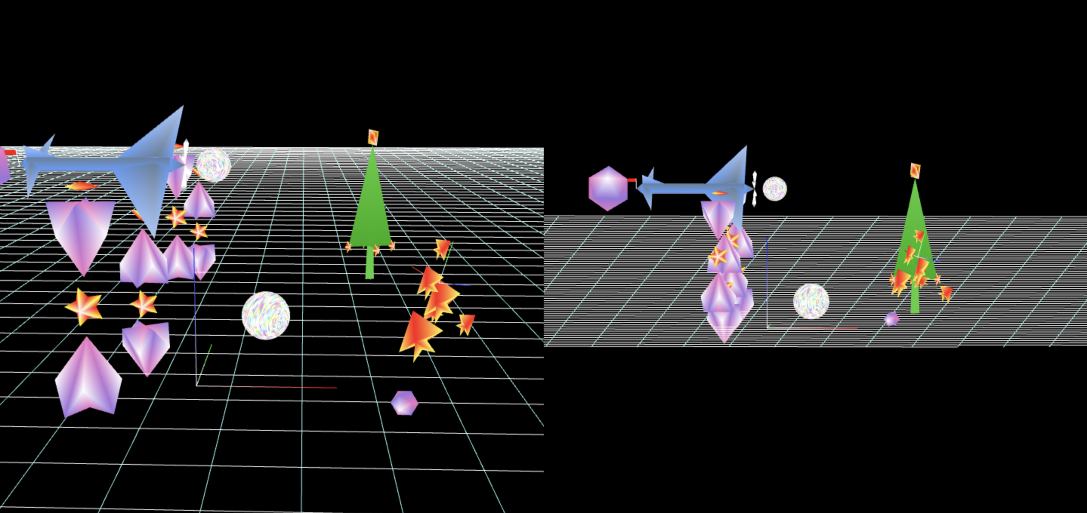

Figure 7 ‘flying-airplane’ navigation control of ‘pitch’

Figure 7 shows a result of ‘flying-airplane’ navigation control of ‘pitch’.

* **Scene Graph**

Figure 8 shows a scene graph diagram of the project. The nodes labeled with T mean a matrix translation. Those labeled with R mean a matrix rotation. The nodes labeled with s mean a matrix scale.

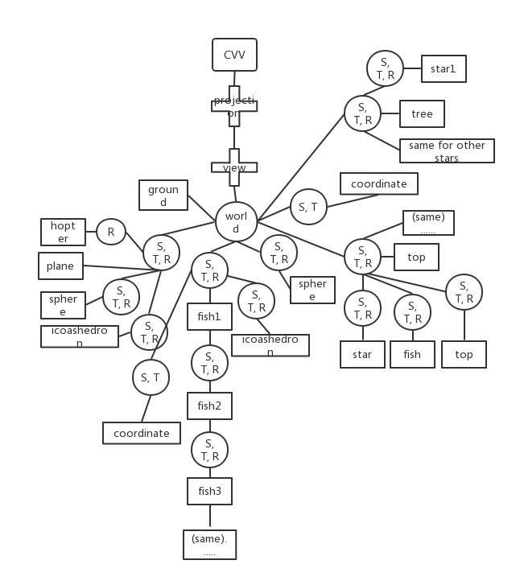

Figure 8 scene graph